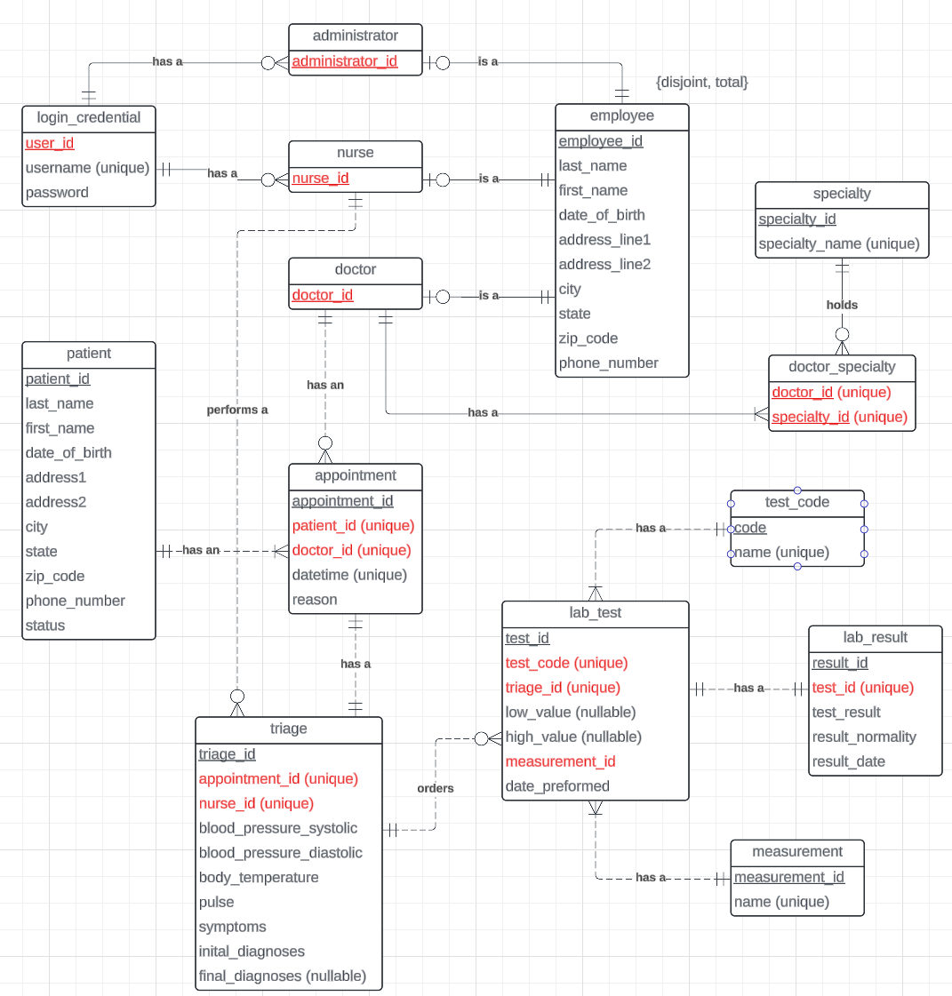

Assumptions:  
The system saves which nurse did the patient's triage  
All records are from within the US and the system do not support another countries  
A triage cannot happen without an appointment  
When the nurse schedules an appointment, a doctor has to be assigned  
There may be no doctor with a specific specialty  
A patient will have at least one appointment in the system  
A doctor may not have an appointment in the system (ex: if they are new)  
A nurse may not have perform a triage in the system (ex: if they are new)

login_credential(user_id, username (unique), password)



employee(employee_id, last_name, first_name, date of birth, address, phone_number)



administrator (administrator_id)



doctor(doctor_id)

nurse(nurse_id)



patient (patient_id, last_name, first_name, date of birth, address, phone_number, status)



doctor_specialty(doctor_id, specialty_id)



specialty(specialty_id, specialty_name (unique))

appointment(appointment_id, patient_id (unique), doctor_id (unique), datetime, reason)



triage(triage_id, appointment_id (unique), nurse_id (unique), bp_systolic, bp_diastolic, body_temp, pulse, symptoms)



lab_test(test_id, test_code (unique) triage_id (unique), low_value, high_value, measurement_id (unique), date_performed)



lab_result(result_id, test_id (unique), result, result_date, normality)



test_code(code, name (unique))

measurement(measurement _id, name (unique))

*Words highlighted in red are unique *together* on the relational schema. (Part two not the diagram)